**GENERAL BROCK PAC DIRECT DRIVE 2021**

**Due Oct. 21st, 2021**

***Hello Brock Families,***

Here at Brock, we are lucky to be part of a small school that fosters a close community. The challenge of a smaller school is fundraising resources.  Some of you may not be aware that the school board does not provide money for extra equipment or experiences for our children.  Our school relies heavily on fundraising to pay for field trips, seasonal events, and educational materials to enrich our children’s school experience.

Over the years our school has worked hard to fundraise and support initiatives.  We no longer have a surplus, and with COVID our fundraising options are limited.  This year our main fundraising source is the **Direct Drive**—an opportunity for us to donate directly.

**Over the past 3 years, Funding from Our Brock PAC has supported:**

* Additions to the primary and intermediate playgrounds
* Building an Outdoor classroom
* Rebuilding the library
* Music Class with a full set of new Orff instruments
* Purchasing two classroom sets of portable laptops and iPads
* Funding numerous school activities (Gardening, Sketch program, Dance)

**This year, Our PAC is planning to support the following:**

* **Library:** $2,000- update the book collection
* **Science and Math Materials:** $2,500 (science subscriptions, videos, and kits)
* **2 Water Fill Stations:** $7,000
* **Outdoor Education:** $2,500 (outdoor covers for rain + updates to PE equipment)
* **Technology:** $5,000 (eg: projectors, carts, whiteboards)
* **K-7 Programs:** $25,000 (eg. Circus West, Dance, music, and SPEC gardening)

*These items are not covered by the school board alone, which is why we are reaching out to see if you can join us in actualizing these programs for our children.*

**We are aiming to raise at least $40,000 to support these initiatives for our children.**

A donation of **$200 per student** would allow us to reach this goal.

We recognize that this amount will not be appropriate for every family, so you will find a drop-down menu with amounts ranging from $20 to $1000.  We also welcome support from grandparents and other relatives, who wish to support their child’s educational experience at General Brock. Please know that any amount is greatly appreciated and helps make significant improvements to our school. Donations are not public and tax receipt will be issued at the end of the year.

We fully understand that a contribution simply won’t be possible from some families, and that’s totally ok! There will also be opportunities to get involved by volunteering at events.  Your donation of time is also truly valued.

# How to Donate

**Steps:**

**1. Login into School Cash online, click on the make a donation.**

**2.** Choose your donation amount and **Select the Brock PAC**. **It is important to select the General Brock PAC otherwise the donation will go directly to the school without input from the parents.**

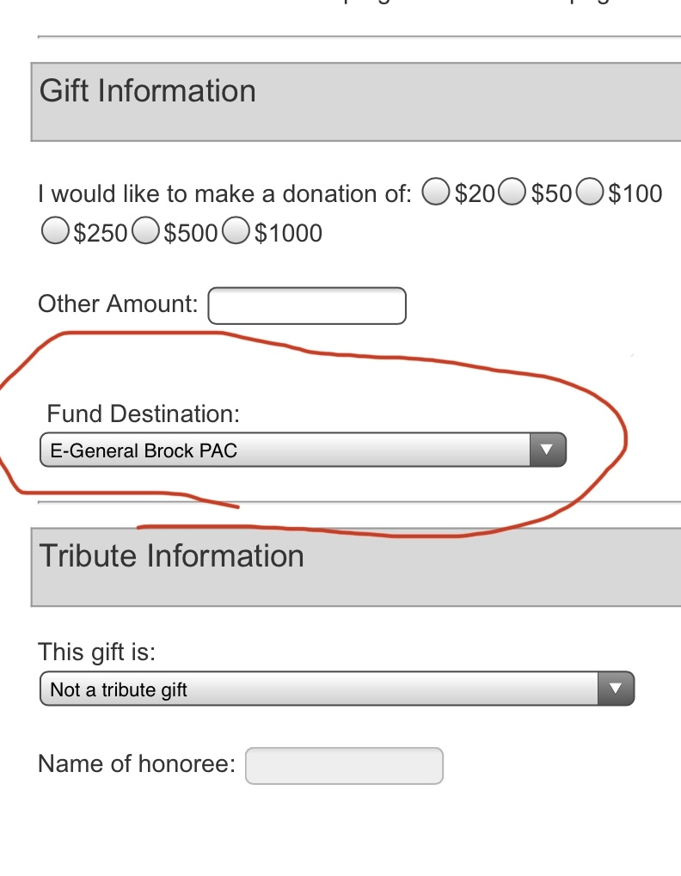

We welcome your comments or suggestions, and are happy to share our financial reporting from the last school year. Please contact [pacbrock@gmail.com](mailto:pacbrock@gmail.com)

# Deadline for donation: Oct 21st , 2021